ILLiad Shutdown Procedures for a Self-Hosted Server

If you are on a shared server, please discuss your transition with your other shared server site code(s) as these changes may affect them. Before shutting down ILLiad, you may want to gather some information. If you would like, 2-3 days before going live, work with your ILLiad SQL Server Administrator to obtain the following information:

* a list of patrons who have articles in a status of “delivered to web” in ILLiad, so that you may contact them via email and remind them to retrieve them in the next 30 days, before your ILLiad access is completely turned off.

On or shortly before the last day that your ILLiad Client is to be active, complete the steps outlined below to finish your transition from ILLiad to Tipasa:

1. **Before you begin any of the steps listed below, please make sure you clear out / process all requests with the following statuses in ILLiad to ensure they will also be available in Tipasa:**
   1. **Awaiting Request Processing**
   2. **Awaiting Copyright Clearance**
   3. **Awaiting Odyssey Processing**
2. **Go to Server Manager and click on Tools Menu**

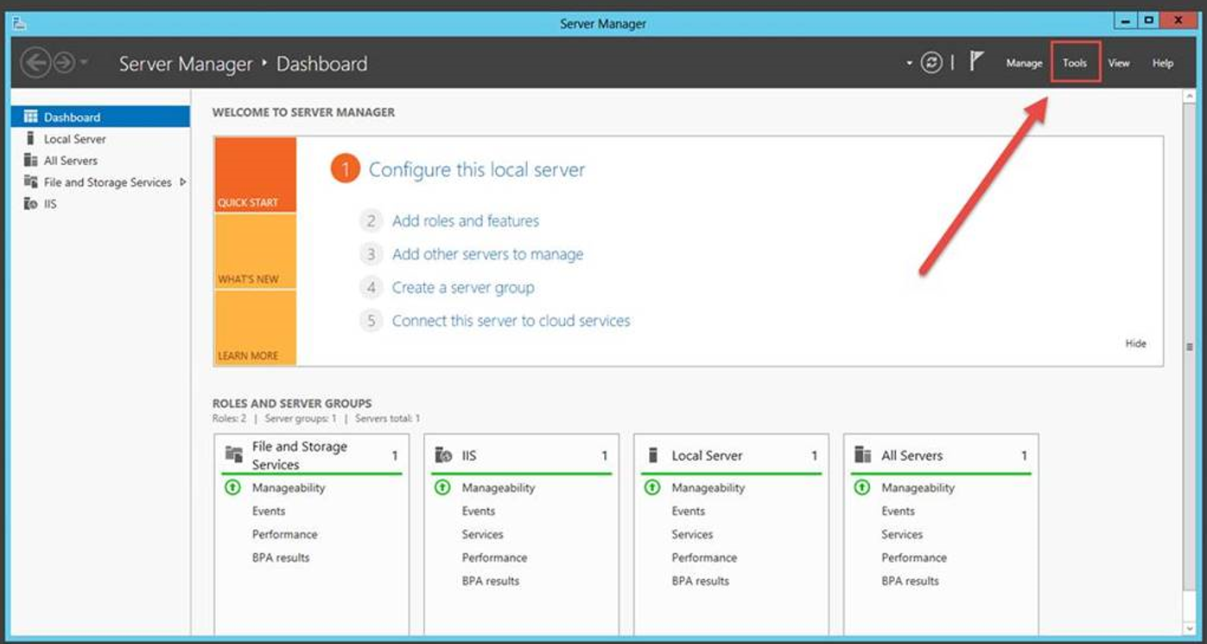

1. **Click on Services**

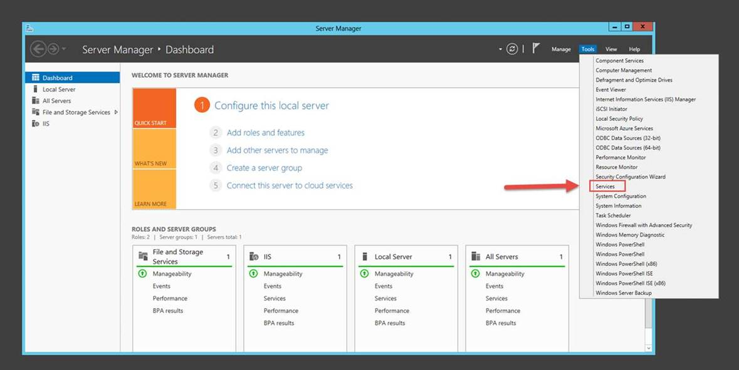

1. **Click on each of the ILLiad services you may have installed (ILLiad Connection Manager, ILLiad ISO Manager, ILLiad Odyssey Manager, ILLiad Rapid Manager, ILLiad System Manager) and change the Startup Type to Disabled and Stop the Service.**

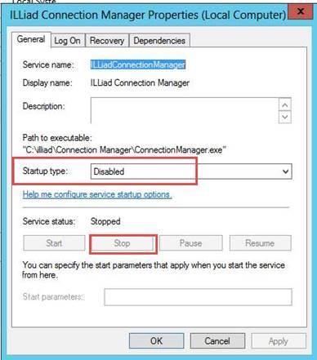

1. **Disable and stop the service for each ILLiad service installed on the ILLiad Web Server:**

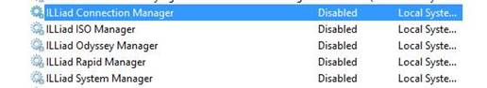

Once you do that, no emails should be going out from ILLiad any longer. This will prevent your ILLiad server from sending and receiving info from OCLC. For our hosted sites, we do this for them a day after they go live, but for self-hosted sites, we cannot do this on your behalf.

1. **NOTE: before completing this step, make sure you have** [**set Article Exchange as your preferred method of electronic delivery**](https://www.oclc.org/content/dam/support/tipasa/implementation/Adding_Article_Exchange_as_your_Preferred_electronic_delivery_method.pdf)**.**

**Delete the ILLiad entry from your Contacts in the OCLC Policies Directory:**

Log onto your Tipasa staff interface:

[**https://YOUR_REGISTRY_ID.share.worldcat.org/wms**](https://YOUR_REGISTRY_ID.share.worldcat.org/wms)

(replace "YOUR_REGISTRY_ID" with your library's OCLC registry ID or vanity/custom URL; e.g., <https://1234.share.worldcat.org/wms>)

First, navigate to the **Interlibrary Loan Home** page, and click **OCLC Policies Directory**

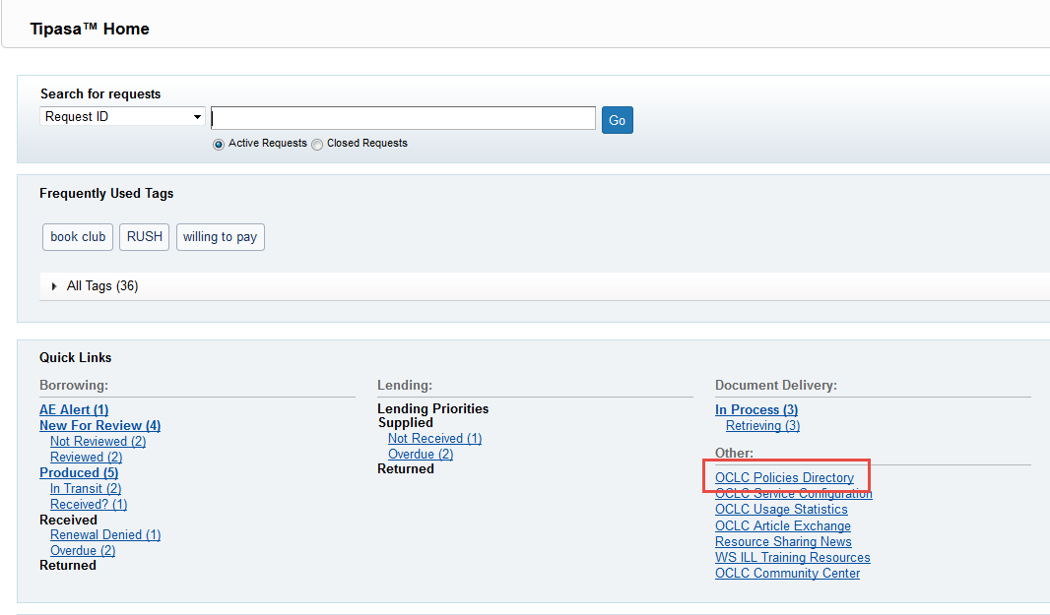

A new tab or window will open for the Policies Directory:

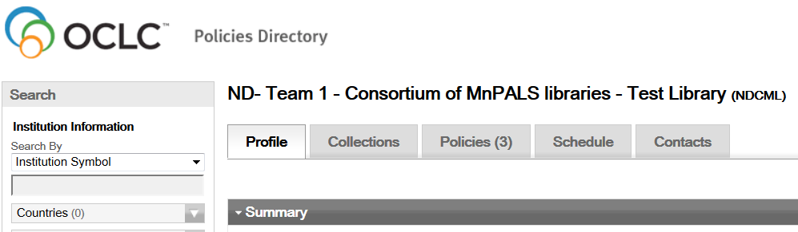

Click on the **Contacts** tab, find your ILLiad entry, and **Delete** it:

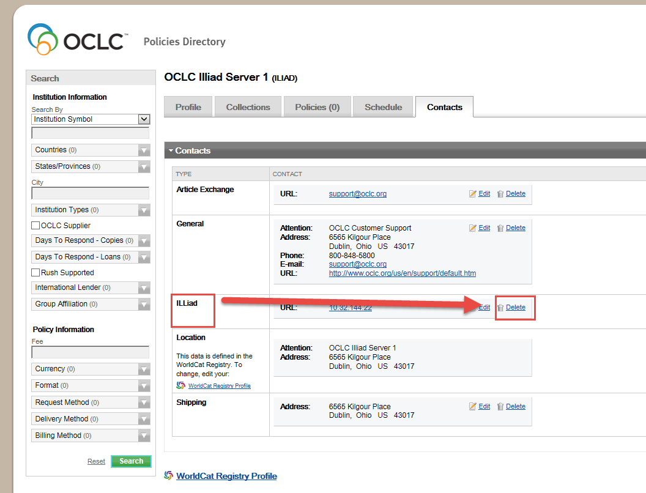

1. **Optionally, you may retrieve reports and statistics from ILLiad Web Reports, by logging onto your ILLiad Client Interface, Clicking System and then Web Reports.**

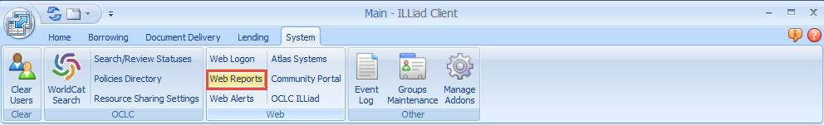

*Note: This may include the Borrowing and Lending Turnaround Statistics, along with your Copyright Report.*

Alternatively, you can retrieve your web reports using Microsoft Access using an ODBC connection.

1. **Replace links to the ILLiad patron form with links to the new forms on your library web pages. NOTE: please make sure you have already set up the Patron Form in Tipasa before performing this step. Click** [**here**](https://help.oclc.org/Resource_Sharing/Tipasa/Configuration/080Patron_Request_workforms/Patron_Request_Workform_configuration) **to access procedures for setting up patron forms.**

https://YOUR_REGISTRY_ID.account.worldcat.org/profile

(replace "YOUR_REGISTRY_ID" with your library's OCLC registry ID or vanity/custom URL; e.g., <https://1234.account.worldcat.org>)

1. **Edit Include_menu.html to remove the New Request section and the Tools section to remove the ability for patrons to place new requests in ILLiad. If desired, you may replace it with this simple file, available** [**here**](https://www.oclc.org/content/dam/support/tipasa/implementation/Include_menu.html)**.**

NOTE: *If the sites are sharing the same webpages, please skip this step. Email the Tipasa implementation team at* [*tipasa_imp@oclc.org*](mailto:tipasa_imp@oclc.org) *to discuss further options on how to prevent your users from placing new requests in ILLiad*

To do this, you will need to FTP to your ILLiad WebServer and replace the include_menu.html file located in the illiad\NVTGC site directory.

## What is still accessible in ILLiad after going live with Tipasa?

* You can access web reports
* Your patrons can access their articles and request history
* There will be no further changes to your database including the addition of transactions